**The Friends of Cannock Stadium Park**

**‘Run for the Community by the Community’**

**Our Constitution**

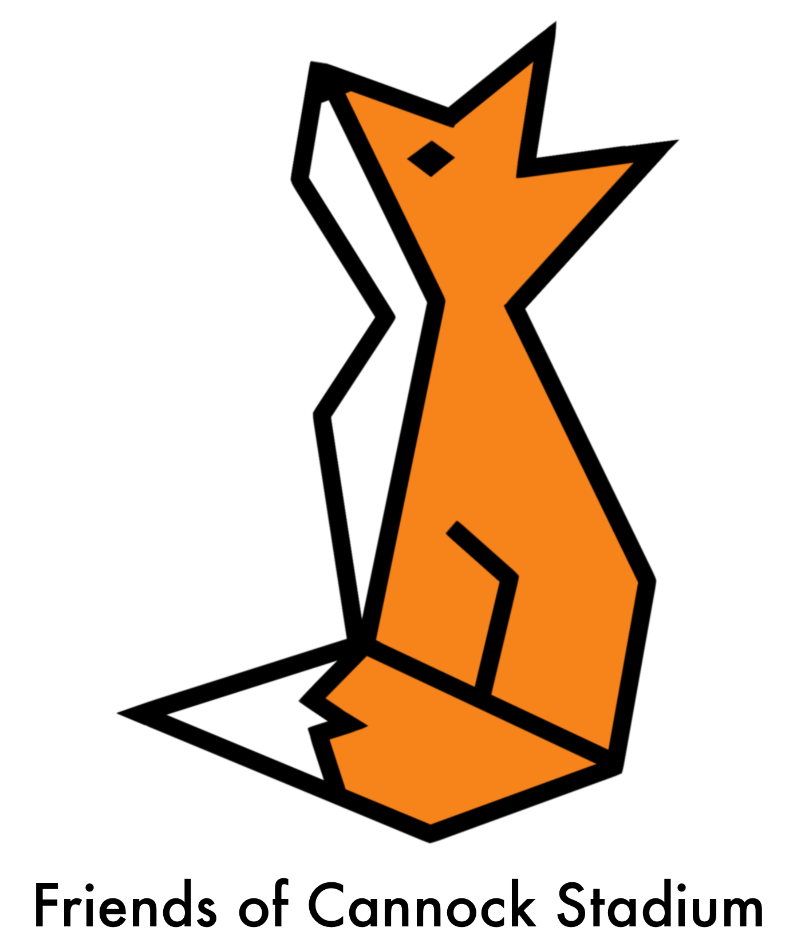

## Our Aims

To help ensure Cannock Stadium Park is a well-maintained and safe public site which can enhance the quality of life for local people by improving their physical and mental health and act as a focus for bringing people together.

**We will work to:**

* To conserve, enhance and promote the park area for the benefit of people, community and wildlife
* To promote and encourage the local community to take an interest in the protection, upkeep and enjoyment of the park and the allotments.
* To actively involve the children and young people of the local communities through working with local schools and youth organisation in the development of Cannock Stadium Park.
* Find out the views of local people and site users and involve site users and local people in planning, decision-making and aspects of management affecting Cannock Stadium Park
* Improve funding to maintain and enhance the site
* Develop relevant and beneficial partnerships with the Council and other bodies
* Encourage more people, from all sections of the community, to use the site and to enjoy its full potential, and promote an atmosphere of mutual appreciation and respect.
* Encourage users, including ourselves, to organise public social activities in the site
* Seek good working relations with other user groups based at the site
* Link with others to help protect and improve green open spaces generally

## Membership of The Friends of Cannock Stadium Park

Membership will be open to anybody with an interest in using the park, regardless of class, race, culture, gender, age or sexual orientation, as long as:

1. they broadly agree with the aims of the group
2. they have given their name and [email] address to be put on to the membership list.

Members will receive information on how to become active in the Friends’ activities and join any working groups.

The group supports equality and inclusivity, and is opposed to racism, sexism, homophobia and other forms of discrimination. Expressions of such prejudice will be challenged at meetings or other activities of the Association.

All members will be asked to follow the Friends of Cannock Stadium Park Code of Conduct and if they do not follow the code of conduct, they may be asked to leave the group, this decision will be discussed by the groups committee members and the final decision will be made by the President.

## The Friends of Cannock Stadium Park Committee

* The Friends of Cannock Stadium Park Committee has the role of overseeing the running of the group.
* The committee shall be a minimum of 4 people, with at least 3 who are not related or cohabitating.
* The committee will meet at regular points to discuss and plan actions for the group. These meetings will occur at least once every quarter.

The committee will consist of at least:

* Chairperson
* Secretary
* Treasurer
* Safeguarding and Welfare Officer

Decisions by the committee will be a majority vote, in the event of votes being tied the chairperson will have a second vote.

**Resignation of Committee Members**

If a committee member wishes to resign their position prior to the AGM they need to inform the Chairperson or Secretary in writing. The committee members resigning must provide a full handover of all work and possessions relating to the group.

## Annual General Meeting

Every year there will be an Annual General Meeting. At this meeting the members will:

* Hear and discuss a report from officers and reps on the activities of the Friends for the previous year
* Hear and discuss a report on the group’s finances, prepared by the Treasurer.
* Decide whether to introduce a membership subscription for the forthcoming year
* Identify and discuss matters of particular importance for the forthcoming year.
* Make rules on the way the Friends group will operate e.g. by amending the Constitution.
* Elect 4 members to be Chair, Secretary, Treasurer and Safeguarding and Welfare Officer
* Amend bank signatories where necessary
* Conduct any other relevant business the meeting so decides

Everybody on the membership list will receive at least two weeks’ notice of the Annual General Meeting by a mailing to the [email] addresses on the membership list and by putting up notices around the site.

## Other General Meetings

General Meetings for members and other park users will be organised and minuted throughout the year. These meetings will be publicised in good time to members and users. At these meetings officers and members of working groups will:

* Keep members up to date with, and discuss, plans and decisions affecting the site
* Collect the views of members and other park users

In addition to the above, members (10 or more) have the right to compel the officers to call an Extraordinary General Meeting on a specific subject.

## Procedure at All General Meetings

The Committee Meetings shall be the decision-making body of the group.

All members will have a right to attend and to vote at General Meetings and Annual General Meeting. Decisions shall be by consensus where possible, or by a simple majority vote where necessary – except for amendments to the Constitution which require a two-thirds majority at the AGM. A quorum shall be 3 members except at the AGM where it will be 4. If

there isn’t a quorum, any decisions made regarding policy must be ratified at the following meeting. The committee may decide to set up working groups, or to delegate any relevant tasks to individual members.

Minutes and/ or action notes should be taken at all meetings, including who was in attendance of the meetings and any apologies.

## The work of the Friends

Members will be encouraged to get actively involved in the work of the Friends. Anyone acting on behalf of the Friends will be expected to act in an appropriate manner, and to follow the general policies and decisions agreed by the members at the General Meetings. Working groups and officers can meet in between the general meetings in order to manage the affairs of the Friends including:

* planning general meetings of the group and other activities
* working on funding bids
* managing Friends’ projects
* passing on the views of members to people responsible for the site such as employees and reps of the Council
* meeting with other community groups
* managing the finances and publicity of the group

Officers and working groups are accountable to members through the General Meetings.

## Finances

A bank account will be set up in the name of the Friends of Cannock Stadium Park. All money received in the form of donations, grants, subscriptions or any other contributions will be put into the bank account and will only be used to further the aims of the group. The Treasurer and Secretary and 2 other members will be signatories, and the Treasurer and one other of the signatories will be required to sign for all transactions. The annual accounts shall be independently verified, and the books shall be made available for inspection on request at the AGM.

## Powers

The Friends of Cannock Stadium Park has the power to raise funds, to employ or hire such staff or advisors as are necessary, and to enter into any transactions necessary to further its aims. It has the power to manage, license, lease or buy property and to maintain and equip it for use. It has the power to appoint a committee, and to take out committee liability insurance cover.

## Dissolution

If a General Meeting, or 10 members, wish at any time to dissolve the Friends of XXXXX, they should give to all members at least 14 days notice of a Special General Meeting to discuss this exclusive matter. If such a decision is agreed at that meeting by a simple majority of those members present and voting, the assets will be disposed of to another voluntary organisation with compatible aims and principles, this group being agreed at the same meeting.

This Constitution was agreed at the Friends of Cannock Stadium Park AGM on 4th June 2023.

Signed (President)

Signed (Vice-President)

Signed (Secretary)